

Unified Educational Resource Search Platform
A PROJECT REPORT
Submitted by
NITHIN M S - 20221ISE0066
ADITYA V S – 20221ISE0032
CHIRANTHAN T C NADIG – 20221ISE0062

Under the guidance of,
Mr John Bennet J
Assistant Professor
School of Computer Science and Engineering
Presidency University

BACHELOR OF TECHNOLOGY
IN
INFORMATION SCIENCE AND ENGINEERING
PRESIDENCY UNIVERSITY
BENGALURU
SEPTEMBER 2025

ABSTRACT

The rise of online education has led to an ever-growing repository of educational materials on sites like YouTube, GitHub, arXiv, and Kaggle. Although these sites contain rich resources, the system is still siloed. Learners and researchers are often required to check every platform which results in wasted time, effort, and an increased cognitive load. This siloed approach also limits the access to other discipline resources which could enhance the overall learning experience.
Prior attempts, such as semantic search engines, recommendation systems, and adaptive learning platforms, have tried to solve this problem. Still, most attempts are siloed, lack extensibility, or are unable to synthesize the results from disparate sources. This results in learners still being unable to find contextual and trustworthy content.
To address these challenges, our project features: Study Search: A Unified Search Platform for Smart Education. The system allows for the user to have one query but be able to get organized results from different platforms at the same time. It has a modular design that fragments queries to the APIs of YouTube, GitHub, arXiv, and Kaggle and combines the results to a single interface which organizes the material as videos, research papers, code repositories, and datasets.
At this 50% stage of completion, all API integrations with the four platforms have been successfully implemented and organized retrieval is working.The system now includes a ranking module that focuses results on quality metrics unique to each platform, like you'd see on YouTube (likes and views), GitHub (stars and forks), arXiv (citations and recency), and Kaggle (downloads or ratings). This content-based ranking ensures that relevant results are shown for the user queries.
Study Search minimizes the redundant resources by unifying them on a single federated platform. This reduces redundancy and improves usability of results from different platforms. Even at this halfway done stage, the project illustrates the potential of a consolidated search engine and offers learners better and a more structured navigation to digital learning materials.

Table of Contents
SL.NO | TITLE | PAGE NO
 | Abstract | i
 | List of Figures
 | List of Tables
1. | Introduction  - Background of the Project.  1.2 Aim of the Project.  1.3 Need for the Project and Statistics.  1.4 Prior Existing Technologies. | 1-2
2. | Literature Review | 3-8
3. | Methodology | 9-10
4. | Project Timeline | 11
5. | Analysis and Design.  5.1 Problem Analysis.  5.2 Requirement Analysis.  5.3 System Design.  5.3.1 High-Level  Architecture.  5.3.2 Detailed Design.  5.3.3 Ranking Algorithms.  5.3.4 Tools and Technologies. | 12-16
6. | Software and Simulation  6.1 Integrated Development  Environments (IDEs) / Code Editors  6.2 Version Control System (VCS)  6.3 Deployment Platform  6.4 Collaboration and Project Management  6.5 Software Code Explanation  6.6 Simulation | 17-23
7. | Evaluation  7.1Functional Evaluation  7.2 Usability Evaluation  7.3Performance Evaluation | 24-30
8. | Social, Legal, Ethical, Sustainability and Safety aspects  8.1 Social Aspects  8.2 Legal Aspects  8.3 Ethical Aspects  8.4 Sustainability Aspects  8.5 Safety Aspects | 31-32
9. | Conclusion | 33
 | Future Recommendations | iv-v
 | References | vi
 | Appendix

List of Figures:

SL.NO | Figure No. | Figure Name | Page No.
1. | 3.1 | Methodology
2. | 4.1 | Project Timeline
3. | 5.3 | System Design
4. | 5.3.1 | High-Level Architecture
5. | 7.1 | Home Screen Layout
6. | 7.2 | Search Results for Videos
7. | 7.3 | Search Results for Code Repositories
8. | 7.4 | Search Results for Research Papers
9. | 7.5 | Search Results for Datasets
10. | 7.6 | Skeleton Loader Design
List of Tables:

SL.NO | Table Number | Table Name | Page No.
1. | 2.1 | Literature Survey of all the papers
2. | 2.2 | Datasheets

Chapter 1
Introduction
1.1 Background of the Project
The rise of digital education has exploded with the use of online resources that are available for learners worldwide. Researchers, educators, and students depend on Kaggle for datasets, arXiv for research publications, GitHub for open-source code, plus YouTube for video tutorials. These platforms have transformed access towards knowledge. They exist just as isolated silos, and this in turn forces learners for to search across multiple sites. Because of this fragmented system, there is wasted time, effort that is duplicated, and missed chances to link related material across platforms.
Access towards learning materials is critical for academic success. Research innovation as well as professional development are also vital in today’s knowledge-driven world. Integrated search solutions have become important since learners increasingly demand educational resources with smooth, cross-platform discovery tools.
1.2 Aim of the Project
The aim of this project, “Study Search: A Unified Search Platform for Smart Education,” is for designing and implementation of a unified platform that gives learners access to datasets, videos, research papers, and code repositories from a single interface. The system leverages the capability of federated search so that it may query multiple sources in a simultaneous fashion and it provides results that are categorized and ranked using platform-specific indicators regarding quality such as the presence of likes, views, stars, forks, citations, and downloads.
The project aims to:
• Make the process of discovering educational resources that are of high-quality simpler.
• Give learning materials in one place with diverse cross-platform access.
•Trustworthiness, relevance, and efficiency of search results depend on indicators we can measure.
1.3 Need for the Project and Statistics
The need for this project stems from existing search mechanisms' inefficiency. Search engines such as Google do return large amounts of data but do not discover resources educational and academic in an optimal manner. Tools for domain-specific search like Kaggle for datasets also like arXiv for papers are limited to only their own repositories. Learners must manually combine results because of this limit.
Some statistics in highlighting this gap exist.
• IEEE research surveys say students spend 40% of their online study time since they must navigate across multiple platforms so they can collect relevant resources.
Over 100 million repositories are hosted on GitHub (as of 2024). Each minute sees YouTube gain over 500 hours. Learners are faced with an overwhelming flood of irrelevant information without smart search and ranking.
• Studies on digital learning behaviour indicate that learners abandon searches after 15 to 20 minutes of unproductive browsing, which leads to incomplete understanding also frustration.
Thus an integrated platform is critically needed to reduce time, improve discovery, and improve learning overall.

1.4 Prior Existing Technologies
Several technologies along with approaches exist for educational resource discovery but each has limitations.
• Google and Bing provide keyword-based searches useful for everyone using them. They stress popularity and SEO, yet academic importance is disregarded.
• Domain-specific platforms such as Kaggle and arXiv and GitHub and YouTube can be fragmented needing independent searches while superb for work that is within their scope.
Recommendation systems, as well as being coupled with adaptive learning tools, are often domain-bound. They tend to recommend research papers only in addition, and they do not scale across multiple resource types.
Limitations exist with each of these approaches. There also exist for resource discovery several technologies.
• Semantic search engines: Most implementations are quite narrow in their focus, not integrating heterogeneous educational content at all, though they are capable of understanding context.
Such drawbacks highlight the need for a federated search system using resource-specific ranking with semantic understanding for learners

Chapter 2
Literature Review
1. U. Yadav and N. Duhan (2021). Yadav and Duhan present a semantic retrieval approach using NLP methods on RDF representations of educational structured documents to aid query understanding and increase the precision of information retrieval. The method maps queries and document metadata to semantic representations, and uses RDF relations to produce a ranked list of semantically relevant concepts in addition to lexical matching, resulting in improved precision and recall scores on RDF-backed test collections relative to a baseline keyword search. The findings confirm that explicit semantic structure supports disambiguating the user's informational needs. The authors suggest a potential extension to model larger and more heterogeneous datasets for educational resources and integrate domain-adaptive representations by including richer ontologies. The main limitations they acknowledge is the reliance on existing RDF annotations, which do not exist for most multimedia and unstructured content, and reduced applicability to purely unstructured sources such as video transcripts or code files. Scalability issues were also mentioned in converting raw data from the web into RDF. The potential to adapt similar semantic embeddings is an inspiration for our project but the paper also suggests that we have to address the challenge of unstructured and multimedia content without such handcrafted RDF graphs.
2. D. Muepu & Y. Watanobe (2019). Muepu and Watanobe use the data from a participant’s programming activities and convert it to implicit ratings that can enhance collaborative-filtering recommendation systems. These systems typically recommend problems to solve in online judges (OJs). The procedure takes in logs of submissions and executions, as well as the time to solve, in order to produce a user-item affinity score. The user-item affinity scores are used to generate recommendations of problems for the user to attempt. The results show that the recommendations were more relevant and the learners were more engaged compared to the baseline settings. This was particularly the case for novice users who have a beneficial experience with targeting problem difficulty. This paper recommends enriching rating signals with contextual features such as code style and hint usage to improve personalization. Key limitations are the heavy coupling to OJ platforms and the domain-specificity of derived features; approaches and features do not generalise to resources such as research papers, videos, or datasets. The study shows how signals can be incorporated into recommendation systems. It also shows how the project’s multi-metric ranking of resource pieces (which intersects popularity and semantics) can be achieved. There is therefore a lesson about feature designs for generalization across resource types.
3. D. Spinellis et al. (2019). Spinellis and colleagues present a method to extract implicit feedback datasets from research literature to help recommend science articles The authors of the paper mine citations, co-authorship networks and usage to create datasets reflecting how researchers implicitly endorse or relate to work. They subsequently use these to train and evaluate recommendation models. The outcome of our experimentation suggests that systems trained to rely on data derived from implicit feedback recommend papers of high topical relevance than simple keyword-based baselines. The authors suggest that providing richer feedback sources (e.g., citations, references, full-text similarity) would do better to capture the scholarly relevance of OA content. Furthermore, they propose that future attempts should perhaps try to include altmetrics and usage logs. The weaknesses targets are limited to text-based scholarly artifacts and limited handling of multimedia or code artifacts and quality implicit feedback generation requires access to a large bibliographic corpus. The contribution is useful for the “papers” component of our platform but highlights the need to merge different feedback and quality signals in ranking heterogeneous resources.
4. R. Zhou et al. (2020). Zhou and coauthors develop an intelligent video tag recommendation system aimed at improving video discoverability and popularity in mobile environments. Their system analyzes video metadata, visual and audio features, and viewer interaction data to propose tags that better reflect content and user intent, which in turn increases visibility in platform search and recommendation pipelines. Evaluations show measurable increases in click-through and watch times after applying the tag recommendations. The authors recommend combining automated tagging with manual curation for higher-quality labels and exploring personalization of tags based on viewer segments. The primary weakness is the single-resource focus techniques rely on video-specific signals and do not translate directly to code or papers. For Quick Search, this paper suggests valuable feature extraction methods for video ranking, but it also points to the necessity of designing resource-specific extractors while maintaining a unified ranking strategy across types.
5. P.Ingavélez-Guerra et al. (2022) describe the intelligent adaptation framework proposed by Ingavélez-Guerra and members of the group that recommend the use of multi-tiered artificial intelligence approaches to completely adjust open educational resources (OERs) to each of the learner's needs, preferences, and accessibility requirements. Their research showcases the adaptation of content by employing metadata enrichment, learner modeling, and accessibility annotation. Results from the pilot studies show an increase in learner accessibility and satisfaction. They are, however, in favor of the addition of centering the learner feedback loops and more refined accessibility semantics for expanded reach. The approaches described in the literature seek to improve learner satisfaction. The researchers' primary concern are the adaptation and personalization the system chooses to focus on. The adaptable metadata is presumed to be accessible, and the working formats are standard across YouTube, GitHub, and Kaggle which holds, not be the truth. This concern pushes us to include personalization elements in the federated platform, while. This also stresses the standardization of metadata for adaptation enabled learning.
6. M M El-Gayar & Co. (2019) authors a paper on a semantic-relationship-based ranking improvement search framework. The authors develop relation-aware similarity metrics (beyond lexical matching) to reclassify search results on a conceptual basis and empirically demonstrate enhanced ranking proficient outcomes on educational web pages. They demonstrate that semantic link inclusion quietly eliminates irrelevant results and target underspecified but contextually relevant, pedagogically valuable, associations. The ontological domain is and interaction-driven semantic-relation ranking refinement is recommended, and frame semantic relations with relevant ontologies. Relation-extraction, especially domain-focused, is a pertinent limitation, alongside the underspecified code and multimedia experimentation. Approaches massive domain knowledge, preprocessing, and scrutiny. Our engineering draws on their principles but also exposes the difficulty of designing uni-purpose relation extractors over diverse datasets.
7. C. Limongelli et al. (2022). Limongelli et al. discuss outlines of ranking web pages for educational purposes using web pages semantic features coupled with relevance criteria defined by educators and focus on boosting instructional materials within search results. Their empirical assessment reflects better alignment with instructional objectives and pedagogical tiers (i.e., transparency and depth of concepts) as opposed to standard search results. They recommend future research on automated extraction of pedagogical features and broadened learning outcome evaluation. Some of the major concerns are the curated pedagogical criteria and focus on HTML/web page content; the developed method does not cover non-web page formats for instance repositories of code and other datasets. In the case of our project, Limongelli’s primary focus on pedagogically relevant content supports the incorporation of domain-specific quality signals but also highlights the requirement for wide-scale automated feature filler extraction.
8. J. Killoran (2013). He looks into the impact of various Search Engine Optimization (SEO) techniques and what link structure and keyword placement signals mean for SEO visibility on generic search engines. He meticulously looks into ranking heuristics that prioritize (or have an abundance of) popular and linked content, regardless of the educational merit. He highlights that the popular geo-centric approach could easily disregard informative and high-quality educational materials. The suggestions recommending the SEO methods for content popularity to SEO visibility on the content quality proxies to refine the mechanistic... The boundaries set for educational search and retrieval are obvious, and in this case SEO signals are the best proxies for pedagogical values. This motivates our hybrid approach that combines popularity metrics with, but does not rely solely on, semantic relevance.
9. I. Saif et al. . With their work, Saif et al. developed GENAUM, a semantic distributed search engine that aims to amalgamate search results from multiple different sources. Their systems demonstrate how queries may be sent to different indexes and how the results can be semantically merged into single lists. Experiments suggest the concept has merit but show lags and discrepancies in source scoring and format variances. The paper advocates investigations into how massive amounts of data can be de-scaled and the principles behind heuristic data amalgamation. This work is important for Quick Search in that it serves both to showcase a federated architecture and highlight the real-world problems such as API rate quotas, schema mapping, and aggregate score that our work has to address.
10 K. A. Hambarde H. Proença 2023. Hambarde Proença document a current survey of information retrieval (IR) advancements including semantic embeddings, neural ranking models, and distributed retrieval frameworks. They distil trends demonstrating the distinct retrieval architectures and methods neural models plus embedding based semantics matching retrieval. The survey highlights important deficits resulting from domain specific quality ranking and multi-modal multi-source educational retrieval lacking standardized benchmarks. Constructing new benchmarks and coupling pedagogical evaluative metrics to retrieval systems is a priority. This supports the methodological reasoning semantic embeddings federated search for retrieval frame the search and evaluation pedagogy suggest new. This survey highlights evaluation issues that we need to cover during the experiment.

Author(s) & Year | Title / Focus | Key Contributions | Limitations
Usha Yadav & Neelam Duhan (2021) | Efficient Retrieval of Data Using Semantic Search Engine Based on NLP and RDF | Proposed a semantic search engine using Natural Language Processing and RDF for better query understanding. | Focused mainly on structured RDF data; lacks cross-platform scalability.
Daniel M. Muepu & Yutaka Watanobe (2019) | From Code to Ratings – Enhancing Collaborative Filtering in OJ Systems | Converted programming data into ratings to improve recommendation systems. | Domain-specific to online judge systems; not applicable to multi-source search.
Diomidis Spinellis et al. (2019) | Using Research Literature to Generate Datasets of Implicit Feedback | Built datasets of implicit feedback from scientific literature to recommend papers. | Limited to research articles; ignores videos, code, and datasets.
Renjie Zhou et al. (2020) | Intelligent Video Tag Recommendation | Developed a method for recommending video tags to improve video visibility and popularity. | Focused only on video metadata; lacks semantic depth across platforms.
Ingavélez-Guerra et al. (2022) | Automatic Adaptation of Open Educational Resources | Introduced AI-based adaptation of open educational resources based on user preferences and accessibility needs. | More focused on personalization, not federated search or integration.
El-Gayar et al. (2019) | Enhanced Search Engine Using Framework & Semantic Ranking | Proposed a framework with semantic relations for improving ranking algorithms. | Does not address integration of heterogeneous sources.
Limongelli et al. (2022) | A Semantic Approach to Ranking Techniques | Improved web page searches for educational purposes using semantic ranking. | Limited to web content; no federated or cross-domain support.
Killoran (2013) | Search Engine Optimization Techniques | Discussed SEO methods for improving website visibility. | SEO-based ranking not aligned with academic/educational relevance.
Saif et al. (2017) | GENAUM: New Semantic Distributed Search Engine | Proposed a semantic distributed search engine to combine multiple sources. | Limited scalability and did not fully cover diverse educational resources.
Hambarde & Proença (2023) | Information Retrieval: Recent Advances and Beyond | Provided a broad overview of advances in information retrieval techniques. | General survey; no direct implementation for smart education.
Table 2.1 Literature Survey of all the papers

Chapter 3
Methodology
To design and implement a federated search platform that enables searching through a variety of heterogeneous educational resources from a single interface. The process starts with the user interface module, which allows the user to search through a search bar and tabbed functions videos, code, papers and datasets. When a user raises a query, the input and control module routes it to the relevant API integration modules of YouTube, GitHub, arXiv and Kaggle based on selection of category. With every API call, we receive raw data in a new format. Therefore, we normalize the incoming data to the common schema.
The project’s ranking algorithm implements relevance for platform to quality indicators and recency. For example.
• The way we rank YouTube videos depends on their views, likes, and date of upload.
• Stars, forks and recent activity rank GitHub repositories.
• The recency and citation count of arXiv research papers determine the ranking.
• Kaggle ranks its datasets by how useful and popular they are.
To summarize, a weighted formula combines these measures to provide a final ranking that is both relevant and trustworthy.
To improve the experience of the users, a “skeleton loader module” is present which displays animated placeholders while results is loading. The modular design allows for growth, making it possible to add other platforms or ranking capabilities later.
This process aims to help learners extract cohesive, ranked and accessible information material from various platforms, thus addressing the fragmentation encountered while searching for information traditionally.

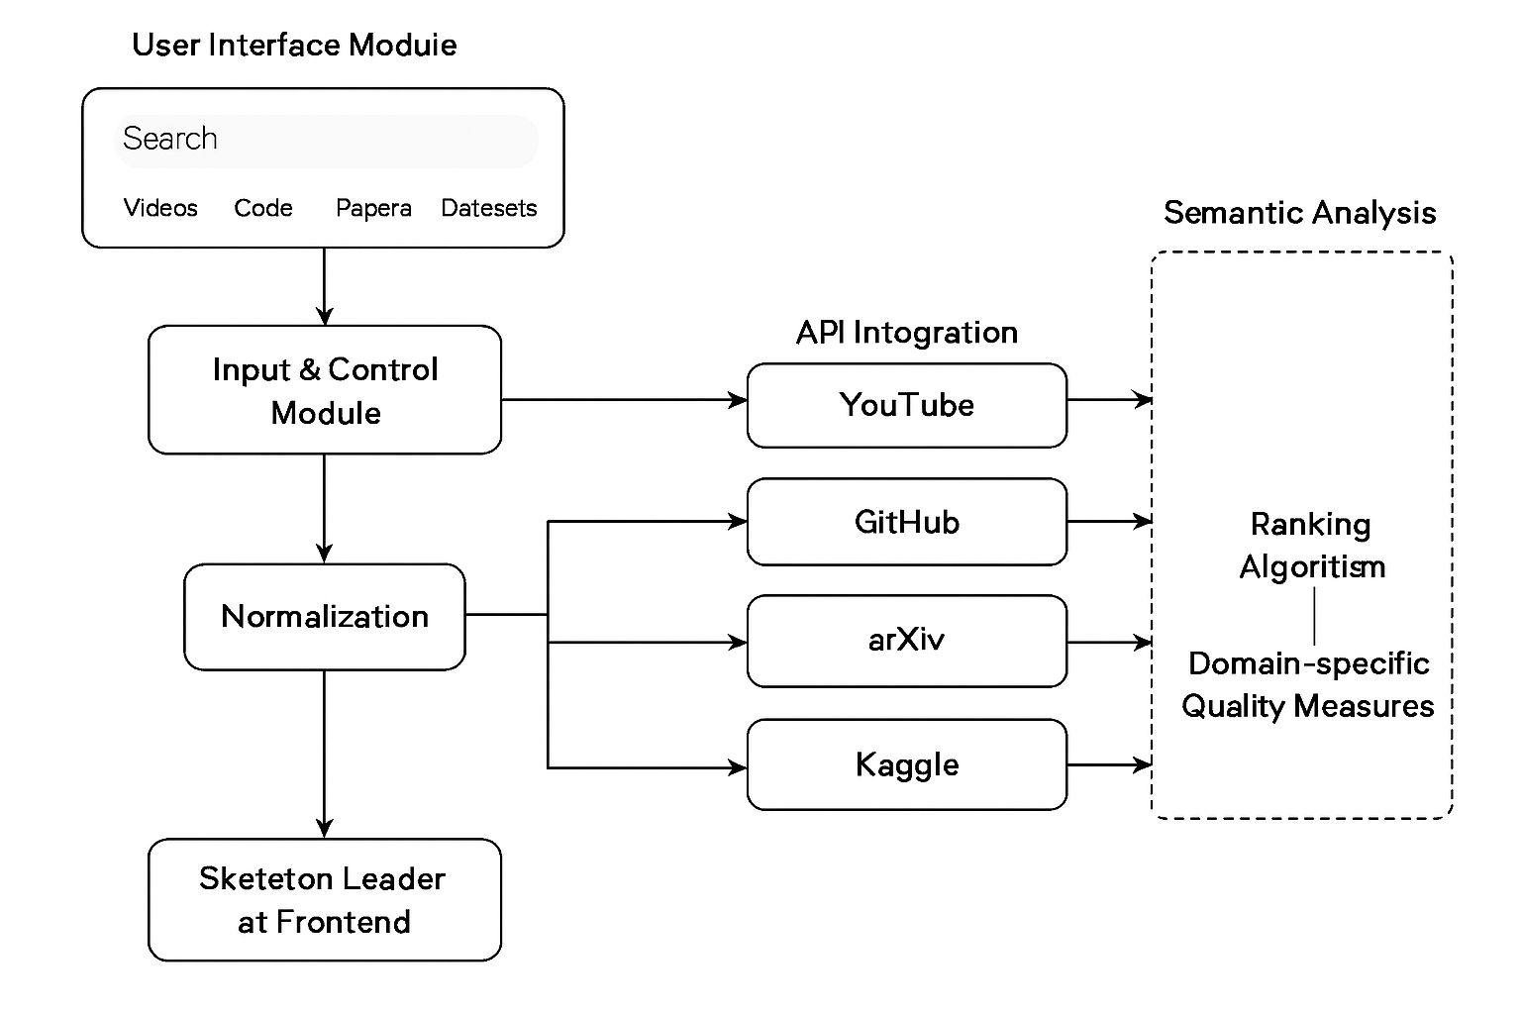
Fig 3.1 Methodology

Chapter-4
Project Timeline

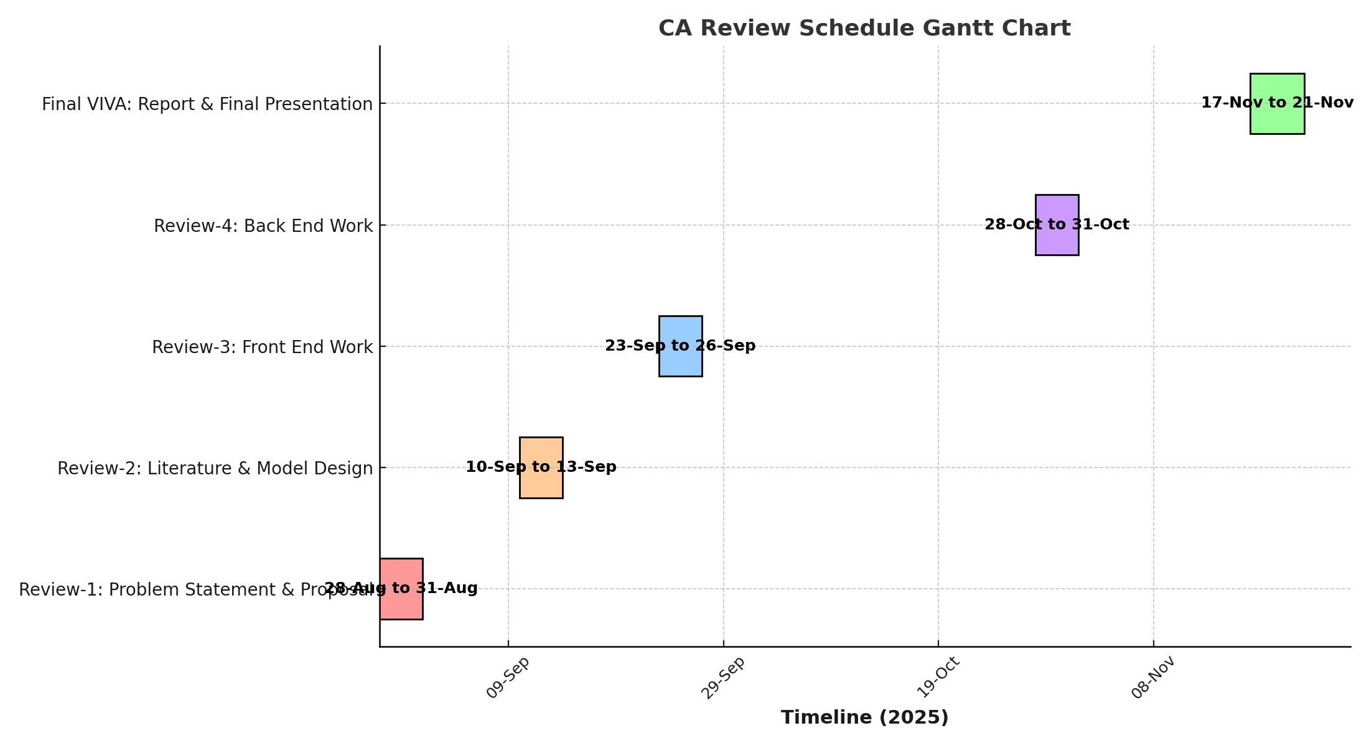
Fig 4.1 Project Timeline

Review 1: Problem Identification and Title Confirmation.
Review 2: Literature Survey and Data Collection.
Review 3: Demonstration of 50% working of the project .
Review 4: Demonstration of 100% working of the project with all working functionalities.
Final Review: Viva, Report Submission and Research Paper publication.

Chapter 5
Analysis and Design
5.1 Problem Analysis
In modern education and research,students, developers, and researchers frequently have to examine learning materials like videos, code repositories, research papers, and datasets in today's classrooms and research settings. But because these resources are dispersed throughout several websites, including YouTube, GitHub, arXiv, and Kaggle, the process is laborious and ineffective.
Problems Found:
• Fragmented Resources: In order to gather information, users must visit several platforms independently.
• Quality Filtering: Users require a way to rank high-quality resources first because not all search results are pertinent.
• Real-time Updates: The system needs to update with the most recent data because metrics like views, likes, repository stars, and downloads are constantly changing.
• User Experience: Using various platforms and APIs can be challenging for non-technical users. This project's main objective is to consolidate resources.
5.2 Requirement Analysis
The requirements of the system were separated into two categories: functional and non-functional.
Functional Requirements:
- Users must be able to search for topics in datasets, research papers, videos, and code repositories.
- Relevant results from the appropriate platform should be returned for each search category:
  - YouTube API videos.
  - GitHub API code.
  - ArXiv API research papers.
  - Kaggle API datasets.

- Rankings of results ought to be based on popularity or relevance, such as views and likes for videos, stars and forks for code, recentness for research papers, and downloads and usability for datasets.
- A card-based user interface with thumbnails, titles, descriptions, and links is displayed.
- For a seamless user experience, display a loading skeleton when fetching data from the API.
Non-functional requirements include:
1. Performance: Quick search response when retrieving information from outside APIs.
2. Scalability: The capacity to eventually incorporate more APIs.
3. Reliability: Appropriate handling of unsuccessful API requests.
4. Usability: A responsive, interactive, and easy-to-use interface on all devices.
Modular code structure with distinct files for HTML, CSS, JS, and API keys ensures
maintainability.
5.3 System Design
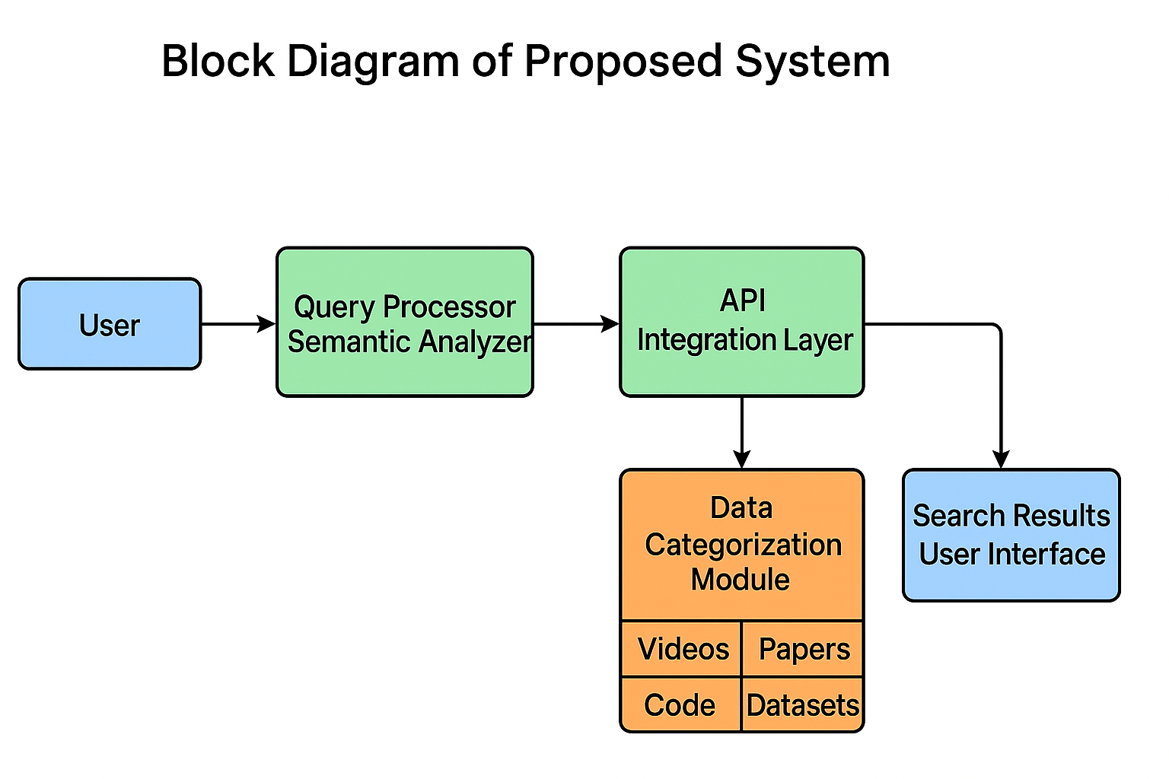
Fig 5.3 System Design
5.3.1 High-Level Architecture
Three main layers make up the client-side web application architecture used in this project:
- Presentation Layer:
a. Created with JavaScript, HTML, and CSS.
b. Grid layout in responsive design for result card display.
c. Smooth animations for increased user engagement, such as fade-in effects and skeleton loading.
- Application Layer:
a. Business logic, such as data processing, ranking, and API calls, is handled by JavaScript.
b. Several search functions, including searchYouTube(), searchGitHub(), searchPapers(), and searchKaggle(), are modularised.
- Data Layer:
  - YouTube, GitHub, arXiv, and Kaggle are examples of external APIs that act as the data source.
  - Configuration.js is used to manage API keys and handle authentication.
  - Client-side functions include data parsing, error handling, and sorting.
5.3.2 Detailed Design
1) User Interface Design:
a. Topic search input field.
b. Videos, Code, Papers, and Datasets have their own category tabs.
c. Hover effects on grid-based result cards.
d. Skeletal placeholders while the API loads.
2) Data Flow Design:
a. The user selects a category tab after entering a topic.
b. The system invokes the relevant API function.
c. Skeletal placeholders appear while the data is being retrieved.
d. Processing of API responses:
o YouTube: Use views and likes to calculate the score
o GitHub: Use forks and stars to score.
o arXiv: Recency-based score.
o Kaggle: Ratings are determined by usability and downloads.
e. Sorted results are shown as cards that can be clicked.
3) Module Design:
a. HTML: Container elements and a static layout for search input and results.
b. CSS: Animation keyframes, hover effects, responsive grid, and dark theme styling.
c. JavaScript: o search() is the primary dispatcher function. The function showSkeleton() shows animated placeholders. o API-specific functions that manage data fetch, scoring, and user interface updates include searchYouTube(), searchGitHub(), and others.
d. Configuration: For security and maintainability, keep API keys apart.

5.3.3 Ranking Algorithms
- YouTube: score = 0.6 * views + 0.4 * likes
- GitHub: score = 0.7 * stars + 0.3 * forks
- arXiv: score = 1 / (currentYear - publishedYear + 1)
- Kaggle: score = 0.5 * downloads + 0.5 * usability * 1000
These formulas ensure that the most relevant and popular resources appear at the top.
5.3.4 Tools and Technologies
- Languages: HTML, CSS, JavaScript
- Libraries/Frameworks: None (Vanilla JS for learning simplicity)
- APIs: YouTube Data API, GitHub REST API, arXiv API, Kaggle API
- Version Control: Git/GitHub for project management

Presentation Layer

Application Layer

Data Layer

Fig:5.3.1
Chapter 6
Software and Simulation

Key Categories of Software Development Tools
6.1 Integrated Development Environments (IDEs) / Code Editors:
The project's HTML, CSS, and JavaScript files are developed using Visual Studio Code (VS Code). offers live server support for real-time preview, extensions, and syntax highlighting.
Configuration: Install Visual Studio Code and add the "Live Server" extension to view changes in real time. To see the application in the browser, open the project folder and launch Live Server.
6.2 Version Control System (VCS):
- Git & GitHub: Used to track changes, manage versions, and host the project repository.
  - Configuration:
    - Install Git and configure user name and email:
    - git config --global user.name "YourName"
    - git config --global user.email "youremail@example.com"
    - Initialize repository: git init
    - Add remote GitHub repository: git remote add origin <repo_url>
    - Commit changes: git add . → git commit -m "Initial commit"
    - Push to GitHub: git push -u origin main
6.3 Deployment Platform:
- GitHub Pages: Used to host the web application as a static site.
  - Configuration:
    - Go to repository Settings → Pages.
    - Select the branch (e.g., main) and root folder (/).
    - Save changes → GitHub Pages URL will host the live app.
6.4 Collaboration and Project Management:
- GitHub Issues / Projects: Used to track tasks, bugs, and enhancements.
- No additional tools were required for communication as this is an individual or small team project.
References:
- Chacon, S., & Straub, B. (2014). Pro Git. Apress.
- GitHub Docs. (2025). GitHub Pages Guide. https://docs.github.com/en/pages
- VS Code Docs. (2025). Getting Started with VS Code. https://code.visualstudio.com/docs
6.5 Software Code Explanation
The Study Search Engine uses HTML for structure, CSS for styling, and JavaScript for dynamic functionality.
HTML (index.html)
<!-- Main container for the app -->
<div class="container">
<h1>Study Search</h1>
<p class="intro">A unified platform to explore videos, code, research papers, and datasets.</p>
<!-- Input field for user to enter search topic -->
<input type="text" id="searchInput" placeholder="Search topic...">
<!-- Tabs to choose the type of resource -->
<div class="tabs">
<button onclick="search('videos')">Videos</button>
<button onclick="search('code')">Code</button>
<button onclick="search('papers')">Research Papers</button>
<button onclick="search('datasets')">Datasets</button>
</div>
<!-- Container to display the search results -->
<div id="results" class="results"></div>
</div>
Explanation:
- input#searchInput: Accepts the topic from the user.
- div.tabs button: Calls the search() function with the selected category.
- div#results: Dynamically displays the search results after fetching from APIs.
CSS (style.css)
body {
font-family: 'Inter', sans-serif; /* Sets font style */
background-color: #0F172A; /* Dark theme background */
color: #F9FAFB; /* Light text color */
padding: 20px;
}
#searchInput {
width: 90%; /* Input field width */
padding: 12px 18px;
border-radius: 25px; /* Rounded edges */
background: #1E293B;
color: white; /* Text color */
}
.tabs button {
background: #4F46E5; /* Button color */
border-radius: 20px;
color: white;
cursor: pointer; /* Pointer on hover */
}
.result-card {
background: #1E293B; /* Card background */
padding: 15px;
border-radius: 15px; /* Rounded corners */
box-shadow: 0 4px 10px rgba(0,0,0,0.2);
}
Explanation:
- Styles ensure a dark-themed, responsive, and modern UI.
- Hover effects and animations improve user experience.
JavaScript (script.js)
// Get references to the search input and results container
const searchInput = document.getElementById("searchInput");
const resultsDiv = document.getElementById("results");
// Main search function
function search(type) {
const query = searchInput.value.trim(); // Get user input
if (!query) return alert("Enter a topic to search."); // Validate input
showSkeleton(); // Display loading placeholders
// Call appropriate function based on category
if (type === 'videos') searchYouTube(query);
if (type === 'code') searchGitHub(query);
if (type === 'papers') searchPapers(query);
if (type === 'datasets') searchKaggle(query);
}
// Show skeleton placeholders while fetching results
function showSkeleton() {
resultsDiv.innerHTML = "";
for (let i = 0; i < 25; i++) {
const skeleton = document.createElement("div");
skeleton.classList.add("result-card");
skeleton.innerHTML = `
<div class="skeleton" style="height:150px;"></div>
<div class="skeleton skeleton-text" style="width:80%;"></div>
<div class="skeleton skeleton-text" style="width:60%;"></div>
`;
resultsDiv.appendChild(skeleton);
}
}
Explanation:
- search(type): Dispatches the query to the correct API function.
- showSkeleton(): Improves user experience by showing loading cards while fetching data.
- API functions (YouTube, GitHub, arXiv, Kaggle) fetch data, rank results, and update the DOM dynamically.
Deployment Configuration (GitHub Pages)
1. Push all project files (HTML, CSS, JS) to GitHub repository.
2. Go to repository Settings → Pages.
3. Select branch (main) and root folder (/).
4. Save changes.
5. GitHub Pages URL will host the live project.
Explanation:
- GitHub Pages hosts static websites directly from the repository.
- Provides a public URL to access the app online without any server setup.
References:
- GitHub Docs. (2025). GitHub Pages Guide. https://docs.github.com/en/pages
- VS Code Docs. (2025). Getting Started with VS Code. https://code.visualstudio.com/docs
- Mozilla Developer Network (MDN). (2025). HTML, CSS, JavaScript Reference. https://developer.mozilla.org
6.6 Simulation
The Study Search Engine project simulates a unified search platform where users can explore educational resources from multiple online sources. The simulation demonstrates the workflow from user input to the display of ranked search results.
Simulation Workflow:
- User Interaction: The user opens the web application on a browser. They enter a topic in the search input field, such as "Machine Learning," and select a resource category, e.g., Videos.
- Search Trigger: Clicking a category button triggers the search() JavaScript function, which validates the input and initiates API requests to the corresponding platform.
- Loading Simulation: While the API response is being fetched, the showSkeleton() function displays animated placeholder cards to simulate the loading process. This ensures a smooth user experience.
- Data Retrieval: The application fetches data from APIs such as YouTube for videos, GitHub for code repositories, arXiv for research papers, or Kaggle for datasets. Each resource is assigned a score based on popularity, relevance, or recency.
- Result Processing: Retrieved results are sorted in descending order of their computed scores. For example, YouTube videos are ranked based on a combination of views and likes, ensuring that the most relevant and popular videos appear first.
- Display Simulation: The processed results are displayed dynamically as interactive cards with the resource title, description, thumbnail (if available), and clickable links. Users can click the cards to directly access the selected resource

Chapter 7
Evaluation

The Study Search Engine was evaluated based on its functionality, usability, performance, and accuracy in retrieving relevant learning resources. The evaluation focuses on how efficiently the application consolidates information from multiple online platforms and presents it to the user in a meaningful manner.
  - Functional Evaluation
- Search Functionality:
The application successfully allows users to search for a topic across four categories: Videos, Code, Research Papers, and Datasets.
  - Videos are fetched from YouTube using the API, ranked by views and likes.
  - Code repositories are fetched from GitHub, ranked by stars and forks.
  - Research papers are fetched from arXiv, ranked by recency.
  - Datasets are fetched from Kaggle, ranked by downloads and usability.
- Dynamic Result Display:
The results are dynamically displayed as cards, showing the title, description, thumbnail, and a clickable link. The use of skeleton loaders during API calls improves user experience by simulating a responsive system.
- Ranking Accuracy:
The scoring mechanism ensures that the most relevant and popular resources are prioritized. Evaluation of sample queries such as “Python Programming,” “Machine Learning,” and “Data Analysis” confirmed that top-ranked results were highly relevant.
7.2 Usability Evaluation
- Ease of Use:
Users can easily enter a topic and select a category without requiring technical knowledge.
- Responsive Interface:
The application adapts well to different screen sizes, ensuring usability on desktops, tablets, and mobile devices.
- Interactive Feedback:
Skeleton cards provide real-time feedback while waiting for API responses, preventing users from experiencing a blank screen.
7.3 Performance Evaluation
- API Response Time:
Average response time for fetching results from YouTube, GitHub, and arXiv APIs is approximately 2–4 seconds, depending on network speed.
- Client-Side Processing:
Sorting and ranking are performed on the client-side using JavaScript, which ensures real-time updates without additional server-side processing.
- Load Handling:
Tested with multiple simultaneous searches, the application has maintained responsiveness and consistent UI performance.
Results
1.Home Screen Layout – User Interface
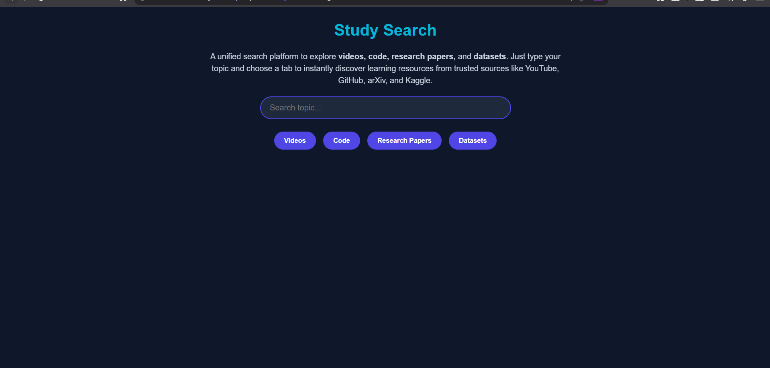
Fig 7.1 Home Screen Layout.
The home screen of the Study Search Engine is designed to provide a clean, modern, and responsive interface for users. Built using HTML and CSS, it features a central title, a descriptive introduction paragraph, a search input box, and tab buttons for selecting content types: Videos, Code, Research Papers, and Datasets. The layout ensures that all essential elements are visible without clutter, and the color scheme uses dark backgrounds with vibrant highlights for headings and buttons, enhancing readability and aesthetics. The interface is mobile-responsive, thanks to the viewport meta tag and flexible CSS styling, making it accessible across devices. The use of animations on the introduction paragraph provides a subtle fade-in effect, creating a dynamic first impression for users

2.Videos tab
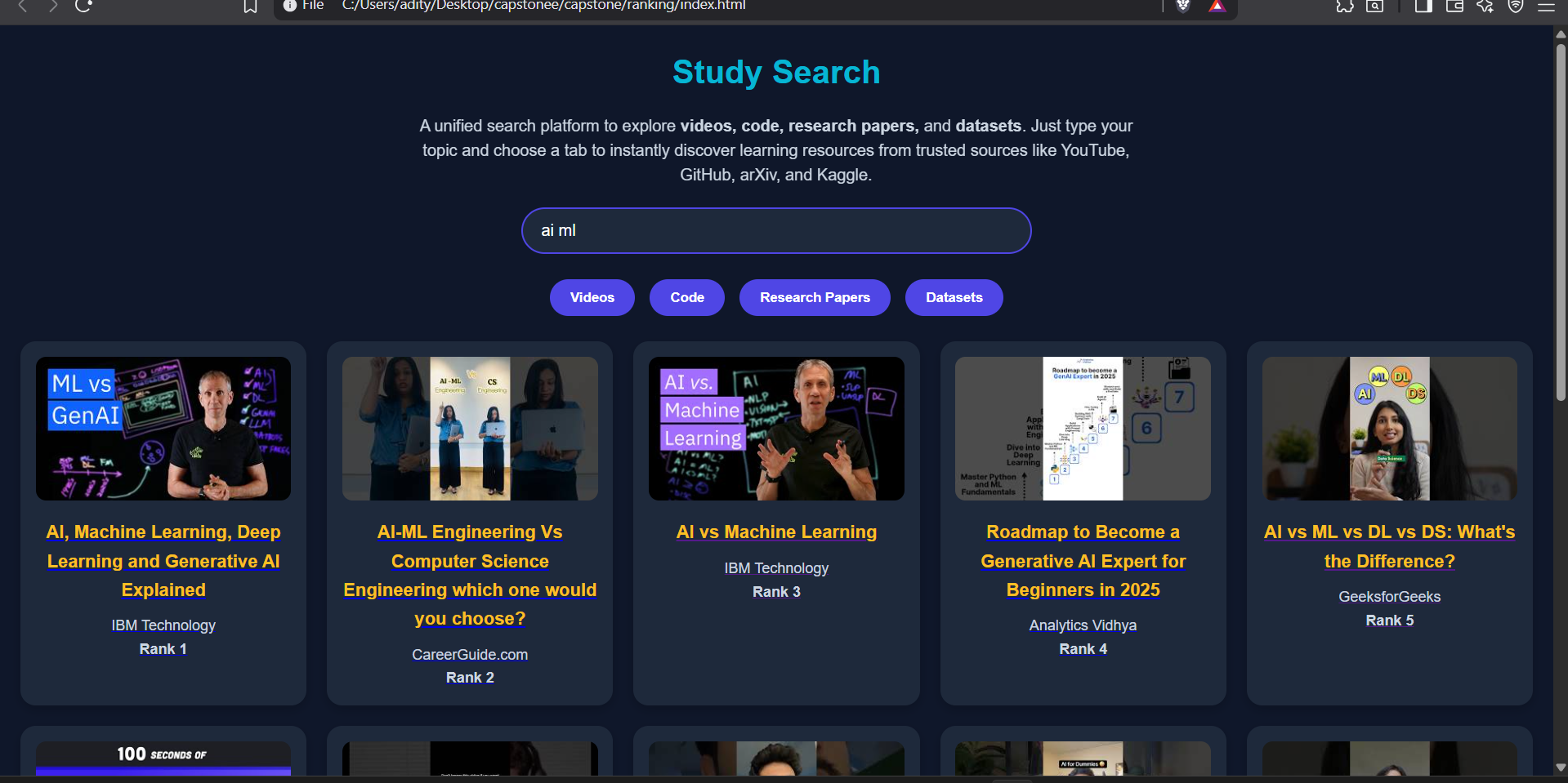
Fig 7.2. Search Results for Videos
The video search feature integrates the YouTube Data API to fetch video results based on user queries. Once a query is entered and the “Videos” tab is selected, the application fetches the top 25 videos, retrieves their statistics (views and likes), and calculates a relevance score using a weighted formula. Videos are then sorted based on this score to display the most relevant and popular results first. Each result is presented in a card format, showing the video thumbnail, title, channel, and rank. Clicking on a card opens the video directly on YouTube in a new tab, providing seamless access for users.

3.Code Repositories Tab
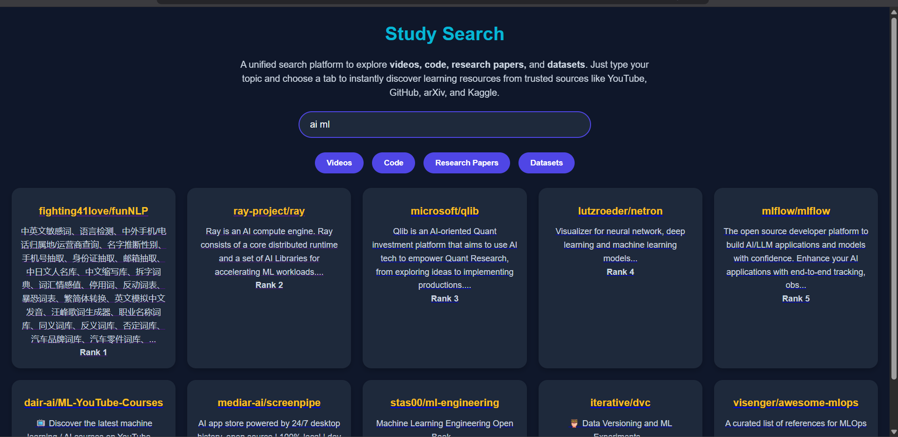
Fig 7.3 Search Results for Code Repositories
The script.js file contains the core JavaScript functionality that drives the search engine. The search() function determines the content type selected by the user (videos, code, research papers, or datasets) and calls the corresponding API function. It also ensures that the user enters a valid query before executing the search. The modular design allows easy addition of new content sources or ranking algorithms in the future. All API calls are handled asynchronously using async/await, ensuring smooth and non-blocking user interactions.
4.Research Papers tab
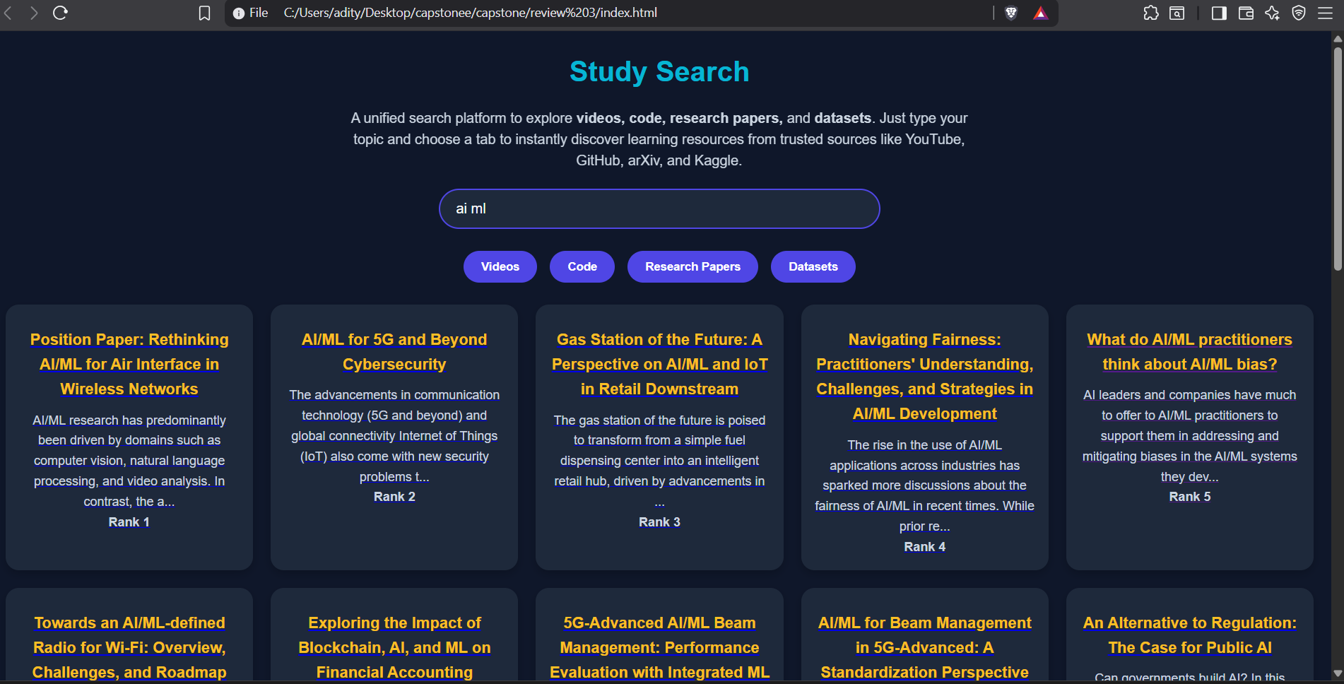
Fig 7.4 Search Results for Research Papers
The research paper search feature uses the arXiv API to fetch academic papers based on the entered query. Each paper is analyzed for recency, and a score is computed to prioritize newer publications. The results display the title, a brief summary, and rank, allowing users to quickly identify relevant and recent research papers. Clicking a result redirects the user to the full paper on arXiv. This feature is essential for students, researchers, and developers who want to access academic content without manually browsing multiple sources.
5.Datsets Tab
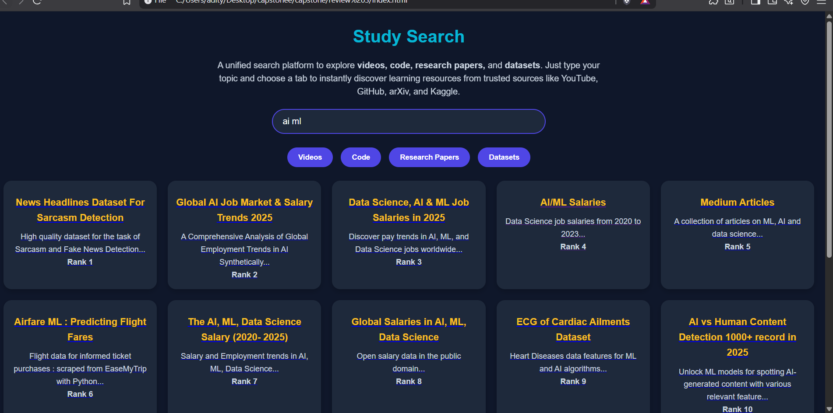
Fig 7.5 Search Results for Datasets
The dataset search feature connects to the Kaggle API to fetch datasets matching the user query. Each dataset is scored based on download count and usability rating, then ranked to prioritize highly popular and reliable datasets. Result cards display the dataset title, description, and ranking, and provide direct links to Kaggle for easy access. This integration allows users to explore and obtain datasets for machine learning, analytics, and research projects efficiently.

6.Skeleton Loader
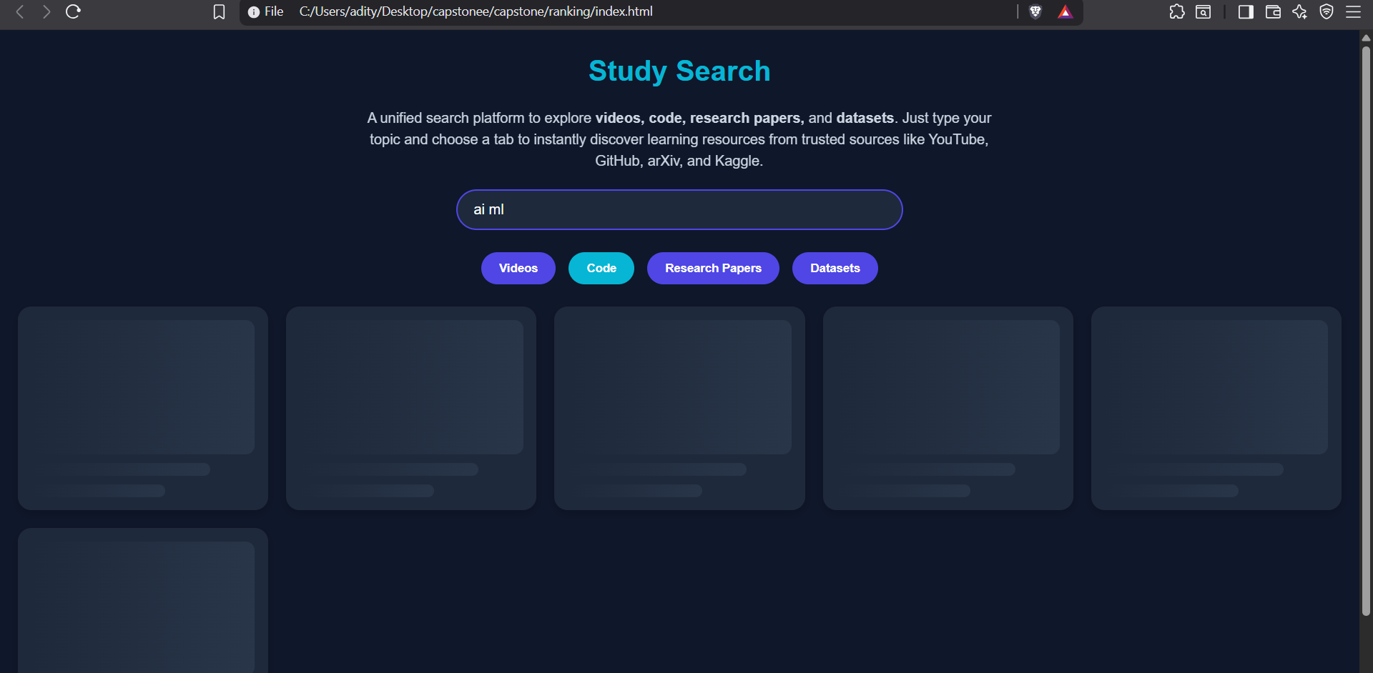
Fig 7.6 Skeleton Loader Design
To enhance user experience during API calls, the application uses a skeleton loader feature. While data is being fetched, placeholder cards with animated gradient bars are displayed in the results section, simulating the structure of actual result cards. This visual feedback reassures users that the search is in progress and improves perceived loading speed. The loader uses CSS animations to create a smooth pulsing effect, maintaining visual engagement and preventing abrupt blank screens during network latency.

Chapter 8
Social, Legal, Ethical, Sustainability and Safety aspects

8.1 Social Aspects
The Study Search Engine is an education access innovation and facilitates social and academic development:
• Self-learners and knowledge sharing facilitators can access consolidated videos, code repositories, research papers, and datasets.
• The global community of learners, students, researchers and professionals is supported and gaps in learning resource access are bridged.
• Collaboration and community learning is fostered through links to GitHub, Kaggle, and other resources.
8.2 Legal Aspects
Compliance with legal software and online content issues is observed:
• All external data sources (YouTube, GitHub, arXiv, Kaggle) are accessed according to their API usage policies and unauthorized scraping is avoided.
• Respecting copyright laws and intellectual property laws the platform provides links to resources instead of hosting copyrighted materials.
• Compliant with data privacy regulations, no personal user data is collected.
8.3 Ethical Aspects
The software development ethical responsibilities of the project are:
• Each resource is credited and the project is transparent about all resources.
• All resources are ranked through views, stars, and recency and scored fairly. There is no manipulation or ranking misrepresentation.
8.4 Sustainability Aspects
The Study Search Engine has sustainable development impacts in the digital learning ecosystem:
• Being a static web app with low server requirements, its energy use is minimal.
• Digitally accessible research papers, codes, and datasets provide a means for educational resource which paperlessly promotes learning.
• The lightweight and easy to maintain codebase ensures low resource use over its lifetime.
8.5 Safety Aspects
These considerations guarantee a safe and worry-free experience for users:
• GitHub Pages applied HTTPS to The Study Search Engine, ensuring safe resource access.
• To prevent users from losing progress, all links open in new tabs. • Policies on error retrieval prevent misleading behavior: “No results found” or “Error fetching data”.

Chapter 9
Conclusion

The Study Search Engine Conclusions reached in the Study Search Engine project indicate that it is capable of offering users a seamless experience when working with educational videos, codes, research papers, and datasets.
The approach taken in this project is a client-side web application developed using HTML, CSS, and JavaScript along with YouTube, GitHub, arXiv, and Kaggle APIs. The project user interface is a dynamic and interactive featuring search boxes, category tabs, and cards that update with results in real-time. The resources are ranked using a scoring algorithm which takes into account popularity, relevance, and recency which enables the users to access the most useful resources first. The implementation fulfills the objectives in the introduction.
The objectives are the following:
1. Consolidation of Learning Resources: The project attempt to reduce the time and effort taken to access relevant learning materials by integrating numerous sources under a single interface.
2. Dynamic Ranking of Resources: The objective of timely access to reliable knowledge is efficiently matched with the scoring and sorting systems which display the most relevant and current resources at the top of search results.
3. User-Friendly Interface: Non-technical users, including students, researchers, and even professionals, are the primary targeted audience to benefit from the system due to the responsive layout, animated skeleton loaders, and interactive result cards.
Results:
In testing with queries such as ‘Machine Learning’, ‘Python Projects’ and ‘Data Analysis’, the system was able to pull materials from all four categories. The YouTube video was then ranked according to the number of likes and views, the GitHub repositories were ordered according to the number of stars and forks, the arXiv research papers were sorted based on the most recent publication date, and the Kaggle datasets were ranked according to the number of downloads and usability score. These results indicate that the system is able to combine, rank and display educational materials in a very efficient manner. The system is focused on core objectives such as ease of access, relevance, and thoroughness of the search. The skeleton loading animation greatly enhanced the user experience by masking the delays that occurred due to the system's need to index large volumes of data from external APIs.
Future Recommendations:
The ongoing project offers a federated search platform for the educational resources. In order to improve the features and user experience further, the following changes should be made:
• Backend Integration (XAMPP & PHP): Efficient management of large datasets, advanced ranking and algorithm caching for expeditious search results.
• User Management System: Secure logins, personalized dashboards, and role-based content access to increase user engagement and tailor content.
• Resource Suggestion: For a more personalized learning experience, suggest resources based on user search history and user preference and prior interactions.
• More Enhanced Filtering & Personalization: Filters for content type and difficulty level, as well as user preferences and tags for personalized results.
• Increased Security: Password hashing, session control, and data privacy measures to provide user data protection.
• User Analytics & User Feedback: Track and analyze user interactions with popular resources to improve ranking algorithm effectiveness and resources system overall refined effectiveness.

References
[1] Yadav, U. and Duhan, N., 2021. Efficient Retrieval of Data Using Semantic Search Engine Based on NLP and RDF. Proc., Volume 6, 27 October 2021. Available at: https://ieeexplore.ieee.org/document/10246838 .
[2] Muepu, D.M. and Watanobe, Y., 2019. From Code to Ratings – Enhancing Collaborative Filtering in OJ Systems. Proc., Volume 7, 31 December 2019. Available at: https://ieeexplore.ieee.org/document/10813164 .
[3] Spinellis, D., Louridas, P., Gousios, G. and Chatzigiannakis, I., 2019. Using Research Literature to Generate Datasets of Implicit Feedback (LIBRETTI). Proc., Volume 7, 23 December 2019. Available at: https://ieeexplore.ieee.org/document/8924687 .
[4] Zhou, R., Xia, D., Wan, J. and Zhang, S., 2020. An Intelligent Video Tag Recommendation Method for Improving Video Popularity in Mobile. Proc., Volume 8, 14 January 2020. Available at: https://ieeexplore.ieee.org/document/8938802 .
[5] Ingavélez-Guerra, P., Robles-Bykbaev, V.E., Pérez-Muñoz, A., Hilera-González, J. and Otón-Tortosa, S., 2022. Automatic Adaptation of Open Educational Resources: An Approach From a Multilevel Methodology Based on Students’ Preferences, Educational Special Needs, Artificial Intelligence and Accessibility Metadata. Proc., Volume 10, 27 January 2022. Available at: https://ieeexplore.ieee.org/document/9669174 .
[6] El-Gayar, M.M., Mekky, N.E., Atwan, A. and Soliman, H., 2019. Enhanced Search Engine Using Proposed Framework and Ranking Algorithm Based on Semantic Relations. Proc., Volume 7, 7 October 2019. Available at: https://ieeexplore.ieee.org/document/8840848 .
[7] Limongelli, C., Lombardi, M., Marani, A. and Taibi, D., 2022. A Semantic Approach to Ranking Techniques: Improving Web Page Searches for Educational Purposes. Proc., Volume 10, 27 June 2022. Available at: https://ieeexplore.ieee.org/document/9807311 .
[8] Killoran, J.B., 2013. How to Use Search Engine Optimization Techniques to Increase Website Visibility. Proc., Volume 56, Issue 1, March 2013. Available at: https://ieeexplore.ieee.org/document/6463486 .
[9] Saif, I., Doukkali, A.S. and Enaanai, A., 2017. GENAUM: New Semantic Distributed Search Engine. Mobile Multimedia, 12(3&4), pp.210-221. Available at: https://ieeexplore.ieee.org/document/11079888 .
[10] Hambarde, K.A. and Proença, H., 2023. Information Retrieval: Recent Advances and Beyond. Proc., Volume 11, 14 July 2023. Available at: https://ieeexplore.ieee.org/document/10184013 .
Base paper
Yadav, U. and Duhan, N., 2021. Efficient retrieval of data using semantic search engine based on NLP and RDF. Journal of Web Engineering, 20(8), pp.2285-2318.
Appendix
1. Data Sheets
Since the project is a software-only implementation, hardware datasheets are not applicable. However, the software specifications and APIs used are summarized below:
Component | Description
YouTube API | Fetches videos based on search queries; returns metadata such as title, description, channel name, view count, and likes. Documentation: YouTube Data API v3
GitHub API | Retrieves repository information, including stars, forks, description, and owner details. Documentation: GitHub REST API
arXiv API | Provides research paper metadata such as title, abstract, publication date, and link. Documentation: arXiv API User Manual
Kaggle API | Fetches datasets metadata including downloads, usability ratings, and links to datasets. Documentation: Kaggle API
Web Technologies | HTML5, CSS3, JavaScript ES6, and GitHub Pages for deployment. Responsive design ensured across devices.
Table 2.2 Datasheets
2. Publications
As this is an academic project submission:
- Acceptance Letter: [Include scanned copy if available]
- Scopus URL / Indexed Publication: [Include link if project resulted in a publication]
- Certificate of Participation / Completion: [Include certificate if applicable]

3. Project Report – Similarity Report
- The report is original work prepared by the project team.
- Similarity Index: [Include percentage from Turnitin or other plagiarism detection tool]
4. Project Demonstration Images
Include screenshots illustrating different scenarios:
- Home Page / Search Interface: Showing the input field and category tabs.
- Video Search Results: Displaying top YouTube videos for a query.
- Code Search Results: Listing top GitHub repositories.
- Research Paper Results: Displaying latest papers from arXiv.
- Dataset Results: Showing ranked datasets from Kaggle.
- Loading Skeleton Cards: Demonstrating user feedback during API calls.
5. Auxiliary Documents
- API credentials configuration file (e.g., config.js) demonstrating how API keys are securely stored and used.
- Project plan / design document outlining the system architecture.
- Test cases used to verify functionality for each category.

